**PROGRAMMING ASSIGNMENT 1**

**Explanation of Dynamic Modelling Approach:**

Euler Langrangian Formulation approach is used to create the model of the robot. It is an energy based system modelling approach.

$$\frac{d}{dt}\frac{∂L}{∂\dot{q}}-\frac{∂L}{∂q}= u$$

where $L=KE-PE$

q = 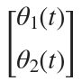

u = 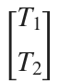

**A: Equation of motion:**

PE = **C:\Users\parth\AppData\Local\Microsoft\Windows\INetCache\Content.MSO\2713B043.tmp**

KE = C:\Users\parth\AppData\Local\Microsoft\Windows\INetCache\Content.MSO\7318D649.tmp

LE = C:\Users\parth\AppData\Local\Microsoft\Windows\INetCache\Content.MSO\5779183F.tmp

**B: State Space Representation:**

**x(t) = C:\Users\parth\AppData\Local\Microsoft\Windows\INetCache\Content.MSO\44CD4AB3.tmp**

**dx(t) =** 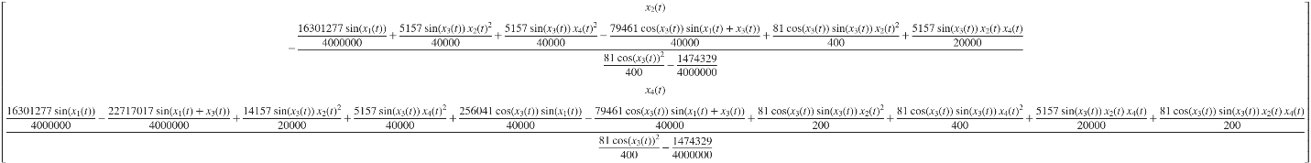

**C,D: Variation of joint angles as per specified inputs and the comparison with Gazebo Simulation:**

|  |  |  |
| --- | --- | --- |
| **Graph Plot** | **MATLAB Output** | **Gazebo Output** |
| $$θ_{1} vs t$$ |  |  |
| $$\dot{θ_{1}} vs t$$ |  |  |
| $$θ_{2} vs t$$ |  |  |
| $${\dot{θ}}_{2} vs t$$ |  |  |

**Possible Reason for discrepancy of curves:** The MATLAB model does not account for Friction and energy losses. This results in an energy constant system which causes it to keep on moving perpetually. The Physics engine of considers losses in system which causes it to slow down with time.